EX. NO: 6
INSTALLATION AND WORKING IN CMD
03.03.25

INSTALLATION:
PYTHON
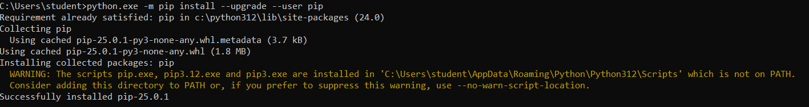
NUMPY
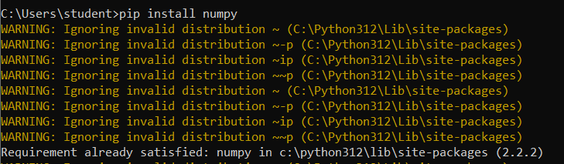
SCIPY
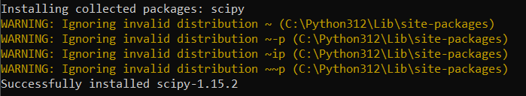
JUPYTER NOTEBOOK
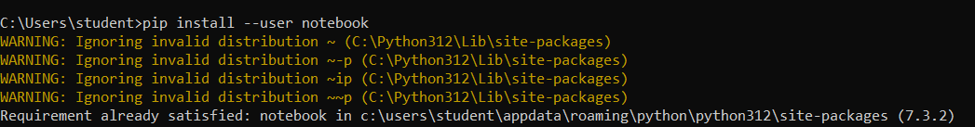
STATSMODEL
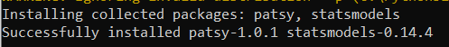
PANDAS:
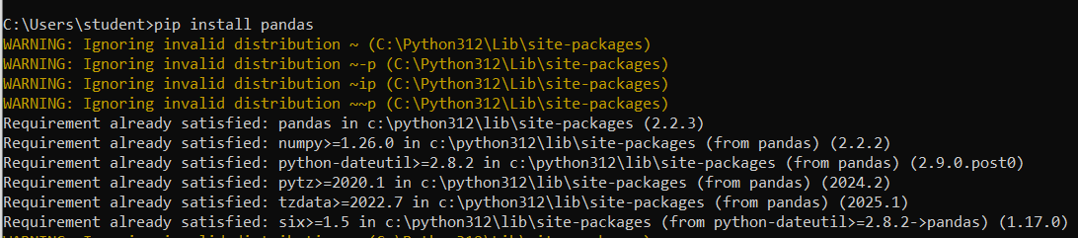
WORKING:
Sample python program in command prompt:
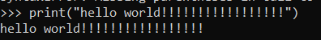
NUMPY
Sample code for numpy usage :
import numpy as np
b=np.array(range(1,20))
print("array",b)
print("shape:",np.shape(b))
output:
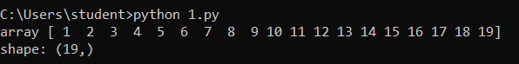
PANDAS
Sample code for pandas:
import pandas as pd
df=pd.read_csv(r"C:\Users\student\Desktop\Iris.csv")
print(df.head())
print("shape:",df.shape)
print("checking null values:\n",df.isnull())

OUTPUT:
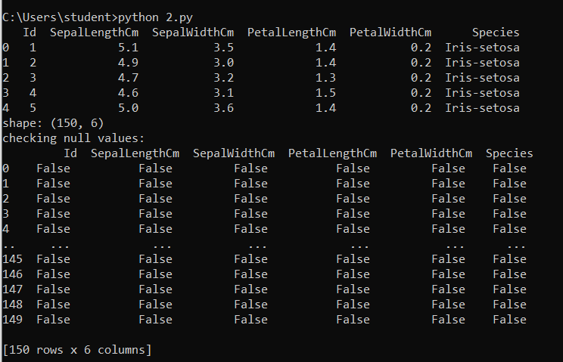
SCIPY
Sample code for scipy:
from scipy.special import factorial
n=16
s=factorial(16)
print("factorial of ",n," is ",s)
Output:
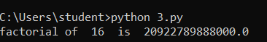
STATSMODEL
Sample code for Statsmodel:
import statsmodels.api as sm
d = [10, 100, 20, 49, 50]
desc = sm.stats.DescrStatsW(d)
print("data:",d)
print("mean : ",desc.mean)
print("median : ",desc.std)
output:
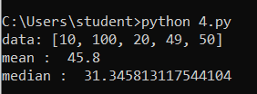
JUPYTER NOTEBOOK-LOCALHOST:
i)Finding installation path and adding jupyter to path
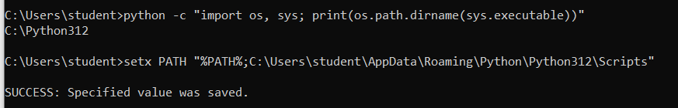
ii)restart cmd
iii)jupyter notebook
jupyter notebook –local host opens in brower

